Small Unit Tactics
Will Serwetman

Introduction

Tactics is a broad subject, and I hardly consider myself an expert. My formal training in the subject is limited to two years of Army ROTC at UMass, so most of the information in this briefing was culled from casual study over the past few years. To conserve time and energy, many sections were pretty much cut, pasted, and re-edited from other sources, which I’ll list at the end. This briefing is intended to serve as a starting point. My goal is merely to cover the basic principles and mentally prepare the reader for practical, hands-on learning. Fighting effectively as a unit requires many hours of training, practice, and experimentation.

Scope

The terms “Strategy” and “Tactics” are often used interchangeably, but they are in fact hierarchal. Both are derived from and subordinate to strategic goals. In warfare, common goals might be: “keep enemies out of our territory” or “establish dominance in this region.” These goals are typically set at a political level, which means that it is a civilian decision in most Western countries. A strategy is a comprehensive, long-term plan on how to achieve these goals. Common examples might include “invade with overwhelming firepower” or “build fortifications around our border” or “blockade their ports.” Tactics are maneuvers that carry out a strategy. These maneuvers can be either large or small in scale: “keep the cavalry in reserve until the enemy pulls his defenders away from his flanks” versus “shoot one enemy and run away; repeat as necessary.” Small-unit tactics are a subset of tactics concerning combat maneuvers on a platoon or squad scale. At this level, the actions of each individual soldier become important.

Objectives

Although tactical decisions may seem rather far removed from the ultimate goal and the basic strategy, they must be kept in mind if “successful” operations are to actually benefit you. As Frank Herbert once observed, “A victory is useless unless it reflects your deepest wishes.” More concretely, a victory is useless if you paid more than you could afford to achieve it, or if that victory doesn’t relate to your end goal. Objectives are to tactics what strategic goals are to strategy. Tactics are formulated with a specific objective in mind that supports the broader strategy. They tend to be simple: “Kill all the bad guys in the area” or “retrieve the downed pilot” or “Figure out where the heck the enemy is and what he’s up to.” Every soldier in the unit should know this objective and the basic plan so that they will be able to respond to changing conditions, such as taking advantage of a sudden enemy weakness, or retreating in the face of an unexpected enemy strength.

Organization

Disorganized mobs tend to have difficulty identifying and achieving objectives. For this reason modern military units are (unsurprisingly) organized hierarchically. Individual soldiers are organized into squads (7-12 soldiers led by a Non-Commissioned Officer or “NCO”), which are then organized into platoons (2-4 squads, 24-48 men, led by a lieutenant), which form a company (2-4 platoons, 56-192 men, led by a captain). Small units typically work in close cooperation with each other, while larger formations are more independent. Battalions are made up of 2-4 companies and support elements led by a major or Lt. Colonel. A regiment consists of 2-4 battalions led by a Colonel; a brigade is 2-4 regiments led by a one-star general, and a division is typically 10 regiments led by a two-star general. Formations larger than that are usually just temporary organizational groups of divisions that exist primarily to accommodate the chain of command. Any unit not formally integrated into the command structure of a military (such as friendly police, militia, or partisans) is considered “irregular.” Western infantry units tend to be a bit smaller than their Soviet-style counterparts and Western armored units tend to be a bit larger, but pretty much every military in the world from Albania to Zimbabwe follows this structure or a slight variant on it.

This hierarchy is absolute and orders go down the chain of command without question. Willful disobedience is punishable by death in virtually all militaries, including the US. Militaries often differ, however, in the degree of detail contained in orders. Well-trained forces trusted by their commanders will rely far more on the discretion of lower ranking-officers closer to the battlefield than more rigidly controlled militaries. Generally, the officers closest to the action are in a far better position to formulate their tactics since they know their own capabilities, the terrain, the weather conditions, and the enemy strength better than higher ranking officers do, so micromanagement is a common sign of poor leadership or distrust of the troops. US Marines, for example, are typically given very general objectives and allowed to achieve them in virtually any way they choose, whereas Chinese infantry platoons are given extremely detailed plans and expected to comply with them or die trying.

Any unit of platoon size or larger is typically led by an officer, while smaller units (squads) are led by Non-Commissioned Officers (NCOs), typically sergeants. Officers will always have a senior NCO assisting them in their duties. Increasingly senior officers have correspondingly senior sergeants assigned to assist them. Lieutenants leading platoons rely especially heavily on the experience and judgment of their Senior NCO in making their decisions, and wise ones will defer to the NCO in most matters, since the sergeant probably has 5-10 years more experience than the lieutenant. Officers are trained to focus on their objective and keeping the operation organized. NCOs, on the other hand, are trained to focus on keeping the unit together- making sure that everyone has water and ammo, that weapons are maintained, and that complaints and suggestions are routed to the commander when appropriate. Ideally, officers are selected for their ability to keep cool and make good decisions under the most stressful conditions imaginable, while sergeants are promoted from the ranks based on their experience and mastery of important martial skills. US forces highly emphasize the role of NCOs, while many forces that have difficulty retaining reliable and capable enlisted men give such jobs to junior officers, typically with poor results. However, even in the US, the lowest ranking officer always outranks the most senior NCO and can give him orders he’s duty bound to follow no matter how strongly he disagrees with them.

In modern US forces, virtually all infantry formations are “mechanized” and ride into battle zones in a vehicle, such as the M113 Armored Personnel Carrier, the more heavily armed M3 Bradley Infantry Fighting Vehicle, or a Blackhawk helicopter. This limits the size of our infantry squads to the capacity of the combat vehicle they are assigned to ride, which is typically 7 or 8 men. Foot-mobile squads (“light infantry”) or truck-carried squads (“motorized infantry”) can be much larger. This is common in lower-tech or irregular forces. Pretty much all US squads are led by sergeants, but some countries place lower-ranked NCOs called “corporals” in charge.

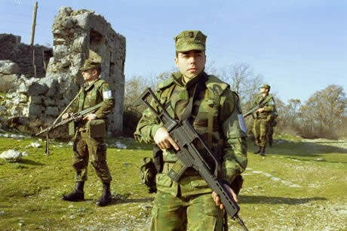
A Spanish Infantry Squad on Patrol

The squad is almost always split into two 'fire teams,' each based around one of the squad's 2 MGs. Unofficially, soldiers are further paired into 2-man buddy teams (sometimes called “battle teams”) for numerous reasons:
- When you’re reloading or have a weapons malfunction you’re helpless unless you have a buddy to cover you. This happens a lot.
- When you’re moving, you want a buddy to lay covering fire and keep the bad guys’ heads down.
- When you’re in the open, you can’t look everywhere at once. Having two people looking around at the same time improves your odds of spotting an ambush or a trap.
- It’s hard to perform first aid on yourself when you’re down.
- It’s just plain scary to be isolated.

Buddy assignments can be fixed or rotated, but everyone should know who they’re paired with at any given time.

Pieces of units are often moved from one formation to another as a unit called a detachment. This term is also applied to semi-autonomous support elements found in battalion-sized or larger units. For example, while artillery can be organized into a single regiment-sized unit, sometimes one or two guns will be detached and placed under the direct command of a non-artillery officer to support his unit.

Individual Equipment

Historically, the structure of military formations have largely been determined by the weaponry of the period. Today, the dominant weapons in small unit actions are the rifle and the machinegun.

Riflemen make up the bulk of infantry forces. As the title suggests, each rifleman carries a rifle. Rifles are shoulder-fired, long barreled weapons capable of accurate fire at relatively long ranges because the barrels have spiraling grooves carved down their length, spinning the cone-shaped bullet and stabilizing it like quarterbacks do when throwing a football. Modern military rifles such as the U.S. M-16 are accurate to ranges of several hundred meters, capable of firing either single shots or full-automatic sprays with each trigger pull, and carry between 20 and 30 rounds in a detachable magazine. Most weigh between 6 and 10 pounds, and are carried either loose in the hand or slung over the shoulder. In addition to the rifle itself, riflemen carry an assortment of essential combat gear in a harness of some sort (web gear). This includes of the tools and products necessary to clean and maintain the rifle, 6-10 extra magazines of ammo, grenades (usually 2-4), and bayonet (used more as a tool than a weapon).

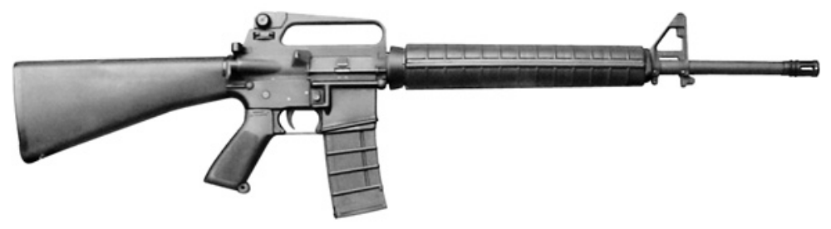
The familiar US M-16A2 Assault Rifle

For protection, most infantry wear helmets (steel or Kevlar) intended to protect the head from shrapnel (shards of metal from grenades or artillery shells). Many also wear “flak vests” to protect the torso as well. Few modern forces issue armor good against rifle bullets because such armor would be much heavier, bulkier, and hotter. This means it would often not be worn and would increase the soldier’s likelihood of getting shot. This is particularly self-defeating since so few wounds are actually caused by rifle fire during military operations. Modern materials are slowly changing this trend, however, and modern US helmets offer some protection against rifle hits. Combat units not expected to stay in combat for extended periods often wear vests of the type worn by police, which will at least reduce the severity of wounds. Full-body armor isn’t likely to be worn anytime in the foreseeable future because it would reduce mobility too much while providing almost no increase in protection—hits to arms and legs are almost never instantly fatal.

During operations, a rifleman will also carry a large backpack called a “Rucksack” or “ruck” containing spare clothes, food, water, an entrenching tool (a folding shovel), and specialized equipment like nightvision goggles. The ruck is not intended to be carried into combat, since it makes tactical movement far more difficult. At the first sign of danger, a squad leader will silence his men, get them down, and have them ditch their rucks.

Soldiers generally wear uniforms printed in a camouflage pattern of some type appropriate for local conditions, although some prefer plain Olive drab uniforms for its low IR signature in night operations or all-black for its intimidation value. Military boots are chosen to offer support and protection for the soldier’s feet, and therefore have thick soles and often have waterproofing. Gore-Tex is an ideal liner material since it lets sweat out but keeps water from getting in. Thinsulate is a second choice because is dries rapidly. Soldiers obsess about their boots only slightly less than they obsess about their weapons.

Officers and NCOs will generally also carry navigation equipment and maps, a sidearm, and a slightly smaller, lighter rifle than most rifleman carry (In the US this is the M4, an M-16 with a 14.5” barrel as opposed to the standard 20”). Platoon radio operators, or “RTOs” (also “Ratellos”), carry a high-powered radio on their backs in addition to the standard equipment. They stay close to the officer in command at all times. Because the radio is likely to be used to call in artillery fire, air strikes, and reinforcements, any soldier carrying or standing near a radio is likely to receive more than his fair share of enemy fire. Modern forces also include more specialized Forward Observers (FOs) whose sole responsibility is to call in and coordinate supporting fire, leaving more conventional communications to the RTO.

Machine gunners are typically chosen from among the larger and stronger members of the squad. The gunner carries a weapon larger than that of the rifleman that is capable of keeping a steady stream of fire. It may look something like a rifle, and in some cases shares parts and ammo with the standard rifle, but more often it will be an entirely different design. In order to quickly and lethally sweep large areas machineguns (“MGs”) must maintain a higher rate of fire than rifles do, which requires a somewhat more complex operating mechanism. The high rate of fire also makes the use of rifle-type detachable box magazines inefficient, since they typically only hold 30 rounds or so and would need to be changed constantly. Most MGs are therefore fed by belts of linked cartridges instead. In addition, the barrels are designed to be replaced quickly (because they can rapidly overheat) and bipods are usually mounted to provide stability while firing and support for the weight. The MG represents a large portion of the squad's firepower and is primarily used to provide covering fire while moving, and to create large kill zones in ambushes and defensive operations. A rifleman will usually be assigned as the machine gunner’s buddy and will be referred to as his “spotter.” He will carry additional ammo for the MG and during combat will identify targets and provide close-quarters protection. If the gunner is killed or incapacitated, the spotter will take over the MG. Units expecting to remain in combat for extended periods will distribute additional ammo belts among the squad. Experienced soldiers don’t mind the additional weight because they know how crucial the constant MG fire is to their survival. Most modern infantry forces assign two machineguns per squad, one per fire team. In the US, three different MGs are in use by infantry squads—The Army assigns one .30 caliber M60, and one lighter and newer M249 (which uses the same ammo as the M16 and can use M16 detachable magazines in addition to belts). The Marines use the Belgian M240 .30 cal instead of the M60.
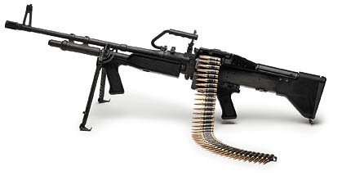
The M60E3 General Purpose Machinegun

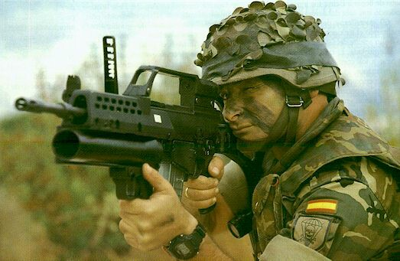
The grenadier is typically an experienced soldier or an NCO. In most modern forces he will carry a rifle like that of the rifleman but with a grenade-launcher mounted underneath the barrel. Like the machine gunner, two grenadiers are assigned to most infantry squads. Grenade Launchers are versatile, capable of launching 35-40mm projectiles of various types, ranging from high explosive to armor-piercing to flechette (big batches of little fin-stabilized darts) to tear gas and smoke. These rounds aren’t effective against modern tanks, but are dangerous to just about anything else. GLs can be used for direct fire at the enemy or, with practice, to indirectly lob the grenade rounds long distances or over obstacles. Other than the GL-equipped rifle, the Grenadier carries much the same gear as the rifleman, but carries additional grenade rounds instead of the full load of rifle ammo.

German Infantryman with G-36 rifle with underslung GL

The Rifleman, the Machine Gunner, and the Grenadier make up the vast bulk of infantry forces. A few more specialized types of soldiers are less common:

At least one medic is assigned per platoon in most forces. There are two schools of thought regarding medics: Most medics in Western armies go unarmed and rely to some extent on being treated as non-combatants. Countries used to fighting adversaries who view warfare less sportingly give their medics rifles or carbines.

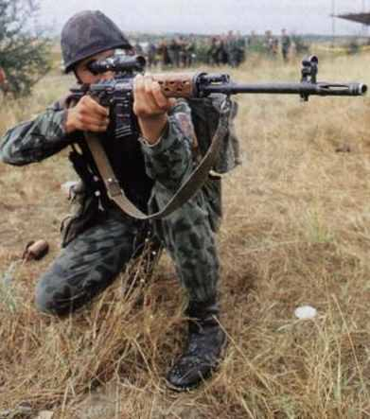
Snipers carry specialized accurate rifles suitable for long-range fire. While many modern rifles are accurate out to 600m, long range fire is a secondary purpose. Sniper rifles have evolved from particularly accurate service rifles with scopes to more specialized weapons built from the ground up for accuracy. The relative merits of semi-automatic weapons (higher rate of fire) and manually operated bolt-action rifles (perfect reliability and better inherent accuracy) are hotly debated and the actual rifles issued to snipers vary radically from force to force. US and British forces now use various bolt-action rifles, while the German and Russian armies use specialized semi-automatics. Similarly, the use of snipers varies greatly among armies. The Army for example, uses them very sparingly, while the Marines assign one or two to most infantry platoons. One recent trend in modern forces is to issue snipers exceptionally large and high-powered weapons (such as the famous M82 Barrett .50 caliber rifle) for use in destroying valuable and fragile targets such as communications gear, missile launchers, vehicles, etc. from distances of up to a mile.
Bulgarian Sniper with SVD semi-auto rifle

As a side note, optical sights are rarely used by riflemen because they are relatively fragile (compared to the blade and notch iron sights built onto the rifles), but this has been changing as modern materials have made sights tougher. Some armies, such as Australia’s, put optical sights on everything from battle rifles to machineguns.

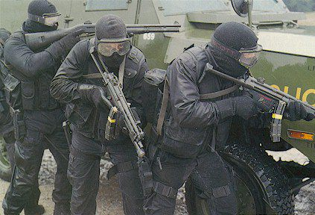
The CQB specialist is the opposite of the sniper. They typically carry a submachine gun (“SMG”) or a combat shotgun instead of, or in addition to, the standard rifle. Submachine guns are compact fully automatic weapons that use pistol ammo, while shotguns are large, rifle-like weapons that have smooth (not rifled) bores and fire dozens of BBs with each shot. The CQB Specialist’s role is to provide maximum firepower against enemies at close range without worrying too much about accuracy.
SWAT Team CQB specialists with shotgun (left) and SMGs (right)

Heavy Weapons Specialists are usually assigned in pairs to operate heavy weapons such as TOW wire guided missiles (WGMs) or Heavy Machine Guns (HMGs) that are typically attached to small infantry units at the company or battalion level. These systems will be described in more detail in the Defensive Operations section.

Individual Tactical Movement

The building block of all combat tactics is individual tactical movement—In other words, individuals moving around so that they can accomplish their objectives while minimizing their odds of getting shot. All militaries use pretty much the same techniques to do this. Since it is nearly impossible to hit anything while you're moving, most movement techniques are associated with a stationary firing position that can be switched to quickly.

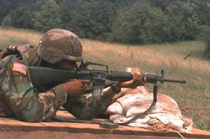
Crawling/Prone: There are two distinct forms of crawling: the first is the “low crawl,” in which the soldier keeps his body completely flat to the ground drags his rifle along by its sling. He pushes himself forward using only one knee or elbow at a time. This is painfully slow, but as safe as movement gets. In the “high crawl” the soldier holds his rifle with both hands in front of him and sort of slithers along the ground both his knees and elbows simultaneously. This is somewhat faster but makes him pop up a little with every movement, providing the enemy with more of a target. The corresponding firing position is the prone, in which the soldier lies on his belly, spreads his legs, holds his weapon to the shoulder and supports it with his elbows. This is the best position for accurate fire, especially if you can brace your rifle on a tree stump or something equivalent. The quickest way to “hit the dirt” and go prone from a standing position is to simply fall forward, making contact with the ground up your leg as you fall and absorbing the final shock of impact with the rifle butt.
A US Army soldier firing from the Prone
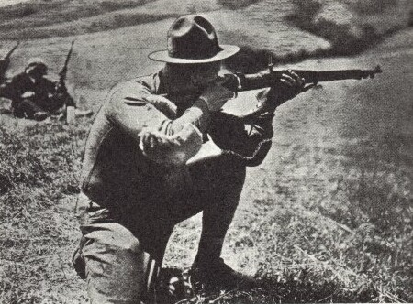
Crouching/Kneeling: Crouching is a good way to move around quickly while making less of a target of yourself. A soldier with his waist bent all the way forward can run nearly as fast as he can with his back straight but provides only half the silhouette. Firing while crouching is uncomfortable, but it’s easy to drop to one knee and settle into a firm, well braced firing position. This isn’t as stable as the prone, but it’s noticeably better than firing while standing.

WWI era US soldier in the kneeling position

Running/Standing: The only time a soldier will stand up in combat is when he needs to move quickly and doesn’t expect to come under fire. A standing soldier makes a big target, and the position provides a less stable base for rifle fire than most. When soldiers stand or run in combat, the usual procedure is to first call for covering fire and to then to be sure to get back down or behind cover in less than 3 seconds, the approximate time required for most riflemen to take aim.

Another important aspect of individual tactical movement is the proper use of cover and concealment. These are things that you will hide behind in combat. The difference between the two is that cover is made of something that you expect to provide protection from enemy fire, while concealment prevents the enemy from seeing you and makes him more uncertain of exactly where to aim. Always use available cover in any type of combat, and concealment if no cover is available. The harder it is for the enemy to see you, the harder it is for him to shoot you. The availability of cover should be an important consideration in deciding where and how to move. In particular, think about use of these types of readily available concealment:
Natural Concealment: Anything that hides you from the enemy's sight. Bushes, grass, trees, geological formations and shadows are all effective.
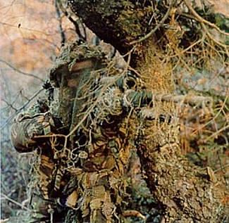
Camouflage: Basically artificial concealment. Usually it involves clothing and equipment with the same colors as the natural environment. Irregular shapes of color are the hardest to see. Adding make-up to exposed skin, and attaching leaves and branches to helmet and clothing are also good forms of camouflage.
Smoke Grenades: Instant concealment. Also, smokes can be used to conceal your retreat. If you are under heavy fire and really need to get away then throwing a smoke grenade around your position can allow you to run away without the enemy seeing you.

Alternatively the smoke grenade can be thrown into an area where the enemy is present. This way it can conceal your attack, but be sure you know where the enemy is standing before you throw the grenade in - you may end up getting lost in the smoke yourself or even shooting your own squad members.

Sniper making good use of camouflage and concealment

Squad Tactical Movement

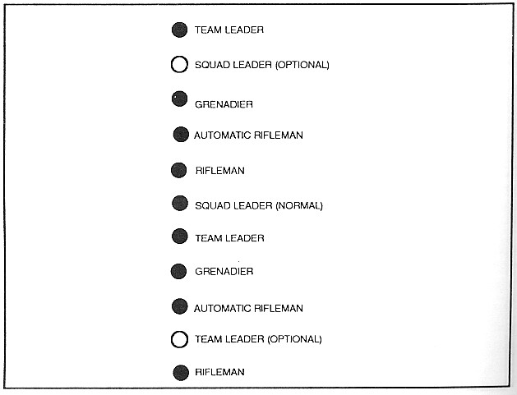
The most important rule of modern warfare is to avoid concentrations while remaining in a cohesive formation. In ancient times forces stayed literally shoulder to shoulder, but modern weaponry makes dispersion essential. As the French learned in World War One, a single grenade or machinegun can kill a whole platoon quite quickly. In Vietnam everyone made a point to keep at least 5 yards apart at all times. The first limit to this dispersion is communications, since you've got to keep close enough so that you can work as a team. The second limit is the need to concentrate attack power. The reason the ancient soldiers massed together was to concentrate their offensive power. In modern times, with long distance weapons, attack can be concentrated while the attackers remain dispersed. Therefore units have to stay close enough to be able to coordinate and concentrate their weapons on a single target. Another consideration is friendly fire. The best way to concentrate fire without “crossing the streams” and risking hitting your own men is to form a rough line (making use of available cover and concealment) facing the enemy. Modern formations tend to reflect the expected threat level, balancing speed of movement against readiness to fight.
The Squad file, suited for fast movement

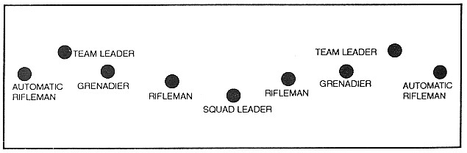
The Squad Line, used to concentrate fire on the enemy
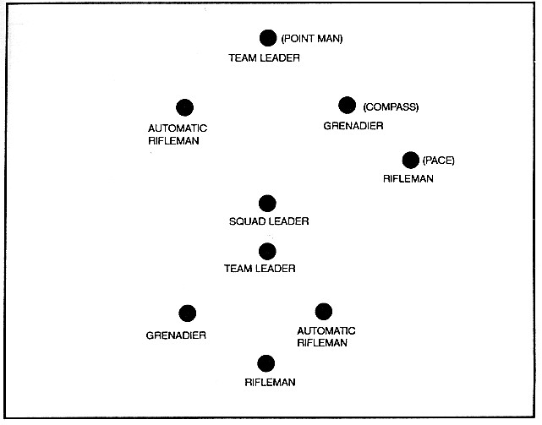
When a unit makes contact with the enemy, they will shift from whatever formation they were in into the firing line. The speed at which a formation can form a line in any given direction determines its combat readiness. When moving through a relatively safe area in a hurry, the team will move single or double file. This keeps them spread out, but allows them to move quickly since they will not have to wait up for individual team members slowed down by obstacles. When moving through more dangerous areas, more “V-like” column formations are more common with the squad leader in the center. This allows the squad to direct substantial firepower to each side and lets the squad get into a battle line fairly quickly no matter which direction the threat comes from.
The Squad Column, in a double wedge-shaped pattern and the Squad Leader in the middle

Once the team forms a line the leader will decide what to do next. The default reaction will be to either close in and assault the threat, or to break contact by leapfrogging backwards and laying covering fire. Both types of reaction will be frequently rehearsed and each squad member will know what his job is in any given situation. No one response will be appropriate in every situation, but soldiers should know the standard responses to at least a few common situations:

A unit’s reaction to an ambush will depend on whether or not the ambushers are within hand grenade range. If they are, it is usually preferable to use the grenades, lay down covering fire and advance, then close in and assault through their position. If they are out of grenade range, the best thing to do is usually to pop smoke grenades, pull back, and flank them. For an example of a good reaction to an ambush, check out Appendix A.

Likewise, if the threat is direct fire from a sniper, all elements should take immediate cover and try to identify sniper's general position. Once identified, leader can decide to engage or disengage.

If the threat is incoming indirect fire, the first person to notice the incoming fire should shout "Incoming!" and everyone should immediately assume the prone position. The team should wait for the first round to impact, and then the leader should clear out of the area. The leader will call out a position, such as “one o’clock, 100 meters!” Once they arrive at the designated location, the leader accounts for all personnel and notifies higher headquarters of the situation. If the fire is guided by an enemy forward observer, this drill should be repeated several times to break visual contact.

A second rule of modern combat is to move only half of your troops at a time whenever possible. One half of the unit should always be in a safe position watching the other half move. The more dangerous the situation, the closer together the two elements should stay and the more frequently they should switch. When contact is most likely, the elements should be alternating roles roughly every 50-100 meters, depending on the terrain. When contact is less likely, greater distances allow the unit to move faster. The advantage of this “bounding overwatch” formation is that it keeps accurate suppressive fire available to the moving element at all times.

Suppressive fire is valuable not only because it is more deadly than fire by a team on the move, but because it can pin the enemy down and render them incapable of safely returning fire, at least psychologically. The amount of incoming fire required to pin down a unit is largely determined by the courage, confidence, and aggression of the unit under fire. Training is particularly helpful here, and much of boot camp is intended to prepare soldiers to keep together and follow orders under stressful conditions. A single sniper can immobilize an entire company if he is good enough.

A third important consideration is flanking the enemy. Cover taken to deal with the original threat often leaves enemies vulnerable to fire from their sides. Also, scared people tend to focus all of their attention on the source of their fear and become oblivious to other threats. In combat, amateurs will often submit to this tunnel vision and not even notice incoming fire from his flanks. In addition, linear formations can prevent effective responses to flanking enemies. Since soldiers line up to avoid having to shoot around each other, an attack from the side forces allows fewer people could return fire without risk of hitting their squadmates. At the least, an attack from the flank forces the defenders to redeploy to face the new attackers. If they are still taking fire from their original adversaries then this becomes a lot more difficult.

One way to think about tactical movement is the “OODA loop.” Observer, Orient, Decide, Act. Whoever has the faster OODA loop is very likely to win. First a person observes what is happening and he must orient himself—how does this affect him? Next he must decide what to do about it, and once he has made his decision he must act and the thought process begins again. By aggressively 'pushing' the enemy he has to take longer to go through his OODA loop because he is trying to Orient, Decide what to do and then Act. Meanwhile, he is rapidly losing the initiative and becoming confused. A confused fighter begins to make mistakes and eventually one of those mistakes will be fatal.

Operations in General

Before any operation, a commander should make a detailed plan, starting with an objective and taking into account his own unit’s capabilities and expected enemy capabilities. Provisions must be made for maneuvers, fires, coordination between sub-units, support, transportation, communications, and codes. The plan should be explained in detail to the team using maps and other visual aids. Once everyone understands the plan, it should then be rehearsed several times, preferably mixing it up a few times by swapping soldiers’ positions or changing the scenario a bit.

Reconnaissance is important no matter what type of operation is being conducted. Before any operation is undertaken the commander has to know about the terrain and enemy forces, and the best way to find out is often to send someone to take a look around. This is usually done by 2 to 4 man teams, since the recon element should be able to fight back effectively if they are engaged. At the very least, they have to have two men so they can cover each other’s retreat.

It is important that communications and signals be arranged before a unit goes into action. Any time there is contact with the enemy, either accidental or deliberate, the first man to make the sighting generally has to make a snap decision and give a signal. These signals can be made in a lot of ways. One possibility includes voice, especially for things like "Incoming!" and "Sniper!" where it doesn't matter how much noise you make. Prearranged hand signals are the most common signals. Using a radio or a flashlight is also common. Appendix B lists an important set of signals a team should know and be trained to respond to.

Communication becomes even more important when one realizes how rare actual visual contact with the enemy tends to be. Usually only a few people will be in a good position to see them, and everyone else will have to follow their lead. Units in combat will use lots of cover and concealment, and the longer the ranges involved, the more likely it is to be effective. This usually means that both sides will be simultaneously hiding from each other and trying to kill each other. No one on either side particularly wants to stick his head up to look for the enemy during a firefight, so it is important to yell out where the enemy is when you see him. This can also be done with tracers and smoke grenades. Just because a unit can't see the enemy doesn't mean the enemy cannot be suppressed with a high volume of fire. The important thing is keeping the suppressive fire close enough to the enemy to scare them.

Defensive Operations

Defensive operations are generally simpler than offensive operations. Once the defenders are set up, there aren’t too many mistakes they can make. The most decisive factor in successful defenses is the use of terrain and prepared positions. A good defender will place his troops where they’re nearly impossible to hit and where the attacker will have the least cover of his own.

Whenever a unit stops anywhere potentially unsafe for longer than a few minutes, soldiers are advised to pick good defensive positions and start digging. A hasty fighting position can be dug deep enough to protect a soldier lying prone in a few minutes. These positions can be converted to foxholes by digging them to armpit depth, which usually takes about an hour. Foxholes should be dug such that the soldier fighting can comfortably rest his elbows on the ground and support his weapon. If the unit stays in one place for a long time, further improvements can be added to the foxhole. A deep “sump” can be dug along one edge of the foxhole to kick grenades into and the floor sloped towards it. Foxholes can be expanded to hold two or three soldiers. A roof can be built over it to camouflage it and protect it from enemy fire and the elements. The fighting positions can be connected with trenches. And once the fortifications are “complete” another set of fall-backs can be dug, forming successively smaller defensive perimeters. It’s helpful to have several set up, so that you can abandon the outer one and retreat into new positions. Aggressive commanders will often pursue retreating enemies, which can easily lead their men directly into traps and new fields of fire. The digging never really stops. As Carl Sandburg observed, “the shovel is brother to the gun.” Ultimately sandbags and then concrete bunkers can be built. The toughest of these can even survive big hits from heavy bomber strikes. Positions should be concealed and camouflaged wherever possible.
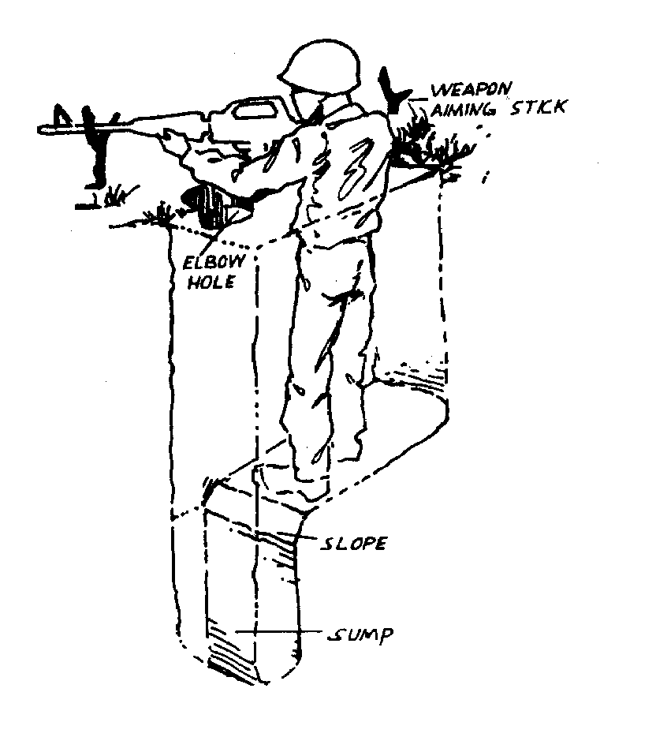
In addition to terrain, the locations of the positions should be selected to allow effective fields of fire, to provide depth, and to allow mutually supportive fire. This means that the defenders in any given position should be assigned a field of fire to concentrate on and leave other areas to other defenders. This ensures that the defenders will be able to monitor and defend a large area effectively. These fields of fire should overlap at the edges to ensure that no gaps exist. Defenses also need depth so that they can absorb the enemy attack and slow down its momentum. While a "thin red line" can be easily breached, multi-layered defenses are much harder for enemy assaults to penetrate. Although the easiest way to provide depth is to have troops spread out in ever-widening defensive circles, this requires a lot of men. In these cases, each position should be able to provide mutual support to neighboring positions. Ideally, each position should be able to bring fire to bear on the approaches to its neighbor’s position and will reinforce the neighbors if they are pressed. Without mutual support, an enemy can easily overwhelm a single position and surge through the gap, flanking the defenders.
A well-constructed foxhole

A strong defensive perimeter also requires a system of watches and patrols to prevent the enemy from catching them completely by surprise. Two-man watches are far more reliable than single man watches, and one-hour shifts are the norm. If a position can spare the manpower, patrols and outlying positions will provide even greater advance warning.

Inside the perimeter, large and heavy crew-served weapons can be set up. These weapons are much more practical for infantry use in defensive operations than offense. Modern US forces favor the Browning M2HB .50 caliber heavy machinegun, the Mk 19 40mm Automatic Grenade Launcher, 105mm artillery, 155mm howitzers, and TOW wire-guided missiles.

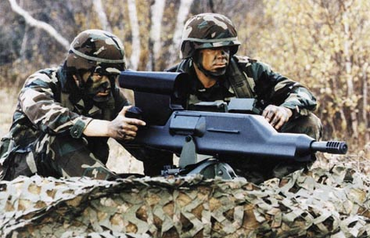
The Objective Crew-Served Weapon, the US’s next generation heavy weapons system

Certain specialized weapons are only practical for area defense, such as boobytraps, mines, claymores, and trip flares. The Claymore mine was developed by the US and has since been copied by most military forces around the world. A claymore is a slightly curved thin plastic box filled with explosives on one surface and thousands of BBs on the other. When activated, usually by wire-connected remote control, it explodes and launches the BBs at more than lethal speed across a wide area. Basically everything in a 60 degree arc 30 meters deep gets hit by the mother of all shotgun blasts. Ouch. Trip flares are pretty self-explanatory- if some one contacts a positioned trip wire, a flare goes off illuminating the area. If there are friendly forces or civilian in the area, it's best to set up flare traps—that way you can get a good look at the intruders before firing on them.

Offensive Operations

Bringing the fight to the enemy carries a distinct set of advantages and disadvantages. On the plus side, you often have surprise and better coordination with support elements. On the down side, you face a lot more unknowns and are likely to face enemies in well-prepared positions.

In offensive operations, most forces split into 3 teams: fire team, strike team, and reserves. Dividing your forces according to their jobs is always a good idea, even in a four-man team:
The Assault Element is the unit responsible for the main attack. An Infantry assault usually refers to closing rapidly with the enemy, blanketing him with fire, and engaging him at point blank range where the defender’s advantages are nullified. In an ambush, they would be assigned different firing areas in the kill zone. Also called the “Strike Team.”
The Support Element is a back-up or reserve unit. Typically they will hang back until the commander sees an opportunity or weakness for them to exploit. In an ambush the Support Element is often set along possible escape routes so that the enemy will be trapped. No matter how desperate a situation may look, it's vital to maintain a separate reserve that can respond to changing conditions.
Security Elements have the responsibility for keeping everyone else safe. In an assault, that means that they will be charged with providing the covering fire enabling the assault element to close in. In an ambush, the Security Element might patrol the back and sides of the ambush point to prevent a rear or flank attack. In other operations, they might act as a blocking force set up to isolate the objective from other hostile forces. The Security Element is also commonly referred to as the “Fire Team.”
There are three basic kinds of offensive operations: Ambushes, assaults, and meeting engagements. Basically, in an ambush the enemy is moving and you’re not, in an assault you’re moving and he’s not, and in the meeting engagement you’re both moving.

Ambushes are the simplest offensive operations. The first step of laying an ambush is choosing a place where you have a good view of the enemy, yet have cover and concealment. Next, the ambusher positions his men and weapons. The “Kill Zone” is the area where you plan on shooting the enemy. It should be a place with limited or no cover, limited escape routes, and little or no opportunity for the enemy to return fire. Most of the ambusher’s firepower will be targeted there. Dead Spaces are areas out of sight of the ambushers. For example, a group on a hill may have a good view of the trail, but may not be able to see into a gully right below them. These areas should be booby trapped or targeted for accurate grenade fire. Then all one has to do is hide and wait. It’s often a good idea to allow the enemy’s point man to pass through the kill zone unmolested in order to trap the main body of their unit.

Assaults can be as simple or as elaborate as the leader prefers, but simple plans tend to work best. Assaults always require at least one fire team to support the assault team’s advance. Whenever possible the attacker should soften the enemy up with indirect fire (hand grenades or mortar shells) to disorient the enemy before the closing in. Such fire is impossible once the assault team is on top of the enemy, so it has to be used then or never, anyway. To prevent friendly fire casualties, the fire team will be usually ordered not to fire into certain zones reserved for the assault team’s approach and the assault team will often be specially marked with glow-in-the-dark tape.

The assault team’s goals will be to get close-in and surround the enemy, denying him the advantages normally associated with defense. Against a well-prepared and determined defender (using the techniques described above), this will be costly and require heavy support and suppressive fire. Tacticians often use the “rules of multiples” when calculating how much force it will take to subdue an enemy force. They are simplistic, but worth paying attention to: 1. It costs twice as much to attack as to defend. History shows us that the attacker, even when wildly successful, loses a lot more men than the defender. 2. Attacking the enemy's flank, or rear attack, is twice as effective as attacking him in the front. Frontal assaults look good in the movies and scare the hell out of the enemy, but usually result in the annihilation of the attacking force. 3. Surprise doubles the effectiveness of any attack. Anytime you do something predictable your chances of getting wiped out are doubled. 4. Defense strength is directly proportional to fortification strength. In other words, holes, bunkers, and trenches can easily double the number of survivors of an attack.

Meeting engagements occur when two forces spot each other at about the same time and engage each other. These are the trickiest and most freewheeling of offensive operations, and tend to combine the elements of offensive and defensive operations at once. Generally the bigger force will pummel the smaller one by brute force and casualties run high, but with some finesse and luck a smaller unit can prevail.

After any successful offensive operation, the attacker must carefully check out the dead and prisoners for weapons and intelligence information. The best way to search the bodies is to work in two man teams. The first man stands about 5-10 meters back from the corpse with his rifle aimed at the corpse’s head while the second man kicks away nearby weapons and searches for maps and documents. If the corpse is face down, the second man approaches from the direction of his feet, grabs each leg by the calf, crosses them, and twists. This way even a big and heavily loaded corpse can easily be flipped over. If the “corpse” is hiding a grenade or a trap, the searcher can let go (turning him back face down) and take cover while the first man shoots the would-be human booby trap in the head.

The best thing to do after the clean-up is often to immediately launch another offensive. By pressing the attack, the attacker can control the tempo of a battle and take maximum advantage of the damage they’re inflicting on the defender. This works best when the attacker has a numerical advantage to start from. Soviet-style doctrine is centered around this use of reserves. In any battle, regardless of scale, the best troops and equipment are held in reserve and committed where the enemy is weakest as soon as the first wave achieves its objectives. Patton was a big believer in this strategy:

“When a man is lying in a shell hole, if he just stays there all day, a German will get to him eventually. The hell with that idea. The hell with taking it. My men don't dig foxholes. I don't want them to. Foxholes only slow up an offensive. Keep moving. And don't give the enemy time to dig one either… I don't want to get any messages saying, "I am holding my position." We are not holding a Goddamned thing. Let the Germans do that. We are advancing constantly and we are not interested in holding onto anything, except the enemy's balls. We are going to twist his balls and kick the living shit out of him all of the time. Our basic plan of operation is to advance and to keep on advancing regardless of whether we have to go over, under, or through the enemy. We are going to go through him like crap through a goose; like shit through a tin horn! From time to time there will be some complaints that we are pushing our people too hard. I don't give a good Goddamn about such complaints. I believe in the old and sound rule that an ounce of sweat will save a gallon of blood. The harder WE push, the more Germans we will kill. The more Germans we kill, the fewer of our men will be killed. Pushing means fewer casualties. I want you all to remember that.”

Mechanized Operations and Combined Arms

Small units of infantry often work with other arms. Most often this means the armored personnel carriers that transport and support infantry operations, but this can also refer to Tanks, Artillery, helicopters, etc. Nothing draws fire on the battlefield like a moving tank (Armored Fighting Vehicle). This is for good reason—tanks have awesome firepower, with several heavy machine-guns and a main gun firing 40 pound high explosive or Armor-piercing projectiles. Tanks aren’t invulnerable, but they are damn hard to kill. Any modern tank’s armor is completely impervious to rifle and MG fire, so the only ways an infantryman can take one out are with a couple hits with portable anti-tank guided missiles or getting close-in and planting satchel charges or limpet mines.

Despite their awesome firepower and substantial protection, tanks do have a few weaknesses. First, they can’t sneak up on anyone—they’re big, loud, and kick up loads of dust when they move. They even leave blatantly obvious tracks almost everywhere they go, including paved roads. Also, they’re relatively blind, since big viewports would make the vehicle vulnerable to enemy fire. The crew can only see outside through periscopes unless they stick their heads out of the hatches. Good tank commanders keep their heads out and spot threats quickly (but tend to be short-lived in the event of an ambush or sniper attack). This makes sneaking up on a tank or getting away from one relatively easy. If one can get within 10 meters, the tank crew won’t be able to see them without opening a hatch. The most vulnerable spot on tanks is the treads, which makes immobilizing tanks much easier than killing them. An immobilized tank may stay in the fight, but once it’s stationary it’s only a matter of time before it gets hit by artillery fire, missiles, or a close-in assault by infantry. The best way to immobilize a tank is with a strategically placed field of large anti-tank mines.

On their own, tanks tend to keep about 100 meters apart and operate in pairs, leapfrogging each other. This way one tank can keep watch while the crew of the moving tank keeps safe and “buttoned down” with the hatches closed. This also works well because tanks, especially less sophisticated ones, fire much more accurately while stationary. Tanks are great for defense, since they can position themselves on the downslope of a hill with only their heavily armored turret presented to oncoming attackers. This is a hard target and can do some serious damage very quickly. Typically engineers will bulldoze several such positions for defending tanks so that when the enemy starts to close in, the tank driver can just throw it into reverse and take a similar prepared position on the next hill, and then the next.

Working together, tanks and infantry can cover each others’ weaknesses quite effectively. Infantry serve as the eyes and ears of the tank, spotting targets, clearing away hazards, and preventing hostile infantry from getting too close. In return, the tank draws fire, provides heavy firepower, and even serves as a shield friendly infantry can hide behind. On the road, infantry often hang onto the sides of a tank for a quick ride to the battle site (Most tanks top speeds are around 40mph, although modern US tanks are considerably faster than this on decent roads). Also, tanks require at least 20 man-hours per week of maintenance to stay combat-worthy, which the crew has to perform at some point. Tanks also need to reload and refuel frequently. Infantry provide security for the tank crew while these tasks are done.

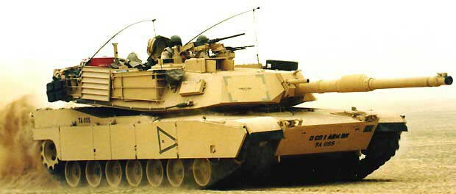
US M1 Abrams Tank on the move

For these reasons, modern infantry formations emphasize combinations of infantry and armor. Nearly all US infantry squads ride into battle in fast, lightly armored tracked vehicles, often mounting a powerful automatic cannon and anti-tank missiles. While these Infantry Fighting Vehicles (IFVs) can’t survive hits from Anti-Tank Guided Missiles (ATGMs) or tank guns, they can handle small arms fire easily and have the firepower to take out a tank on their own. Few countries can afford IFVs though, so most infantry forces rely on less heavily armed Armored Personnel Carriers (APCs) or trucks. In most forces, mechanized infantry and tanks work closely together in mixed battalions.

Indirect Fire and Air Support

When properly utilized, indirect fire is statistically far and away the most lethal force on any modern battlefield. When infantry come across a hostile force, the first thing they’ll want to do is call in support in some form. With surprise and effective guidance, mortar shells, howitzer fire, rockets, or air-dropped mines can wipe out concentrated forces in a heartbeat, and will force even the most stubborn adversary to run for his bunker or foxhole. The munitions involved range from substantial (66mm mortars and helicopter-mounted machineguns, for example) to friggin’ ludicrous (15,000 pound “Daisy Cutter” bombs, 16 inch shell fire from battleships, or Tomahawk cruise missiles). The firepower involved can be incredible, and they can often be delivered with pinpoint accuracy once an infantry force locates the enemy. US forces have used air support to tremendous effect in every war we’ve been involved in since WWII. In Vietnam heavy air support allowed trapped and outnumbered infantry forces to fight off much larger enemy forces just by establishing a strong perimeter and calling in a rain of airstrikes on everything lying outside of it. Close air support by armed helicopter gunships helped the US Rangers and Delta Force operators fight off hordes of Somali militiamen in Mogadishu. Without this type of support, small units can’t survive that sort of lopsided engagement.

The cheapest and most plentiful form of indirect support is conventional tube artillery and mortars. These are simply big guns (66mm to 155mm) that lob a big shell full of explosives ballistically (meaning it goes up and then comes back down). They are cheap, fast to reload and are fairly accurate even without high-tech enhancements. Most artillery pieces are powerful enough to take out a tank if they hit one and will liberally sprinkle a 70ft. area with lethal shrapnel. They can also deliver specialized payloads like poison gas, batches of small anti-personnel mines, or Hiroshima-sized tactical nuclear weapons.

Rocket artillery is also relatively cheap and popular. The idea is to launch volleys of hundreds of small rockets at once to completely blanket a large area with shrapnel. While individual rockets are horrendously inaccurate, they can be extremely effective in large volleys. The downside is that after the volley is spent, it takes a while to load the launchers up again. This isn’t that big a disadvantage, since radar can easily locate the source of a bombardment and direct “counter-battery” fire at the first to fire. This is called an “artillery duel” since the side’s artillery is focused on killing each other as opposed to supporting friendly forces. To allow them to move out of an area before the enemy returns fire, most artillery pieces are mounted on a tank-style chassis or built to be towed by a truck.

Close air support from strike aircraft, attack helicopters, AC-130-style fixed-wing (non-helicopter) “gunships” and even heavy bombers are often available to infantry units of well-equipped forces. Aircraft are particularly useful for hunting tanks, dropping mines, knocking out bunkers, or wiping out massed infantry. The actual munitions involved are constantly improving in terms of both lethality and accuracy, and their effects are gruesome. Air superiority makes life as an infantryman very hard for one’s enemy. The only limitations other than cost are the payload capacity of the aircraft can carry and the relatively short loiter time of which modern aircraft are capable. Shooting down a plane is nearly impossible without big and sophisticated radar or infrared guided missiles, although helicopters are slower and therefore somewhat more vulnerable. Few small units carry dedicated anti-aircraft weaponry, since anything effective is going to be big, expensive, and specialized. Anti-aircraft stuff tends to be either independent and assigned to cover specific areas, or attached to battalion-sized forces.

Urban Operations

The prospect of door to door, house to house fighting scares the crap out of even the most experienced soldiers. The main rule is BE PARANOID. There are enough good hiding spots on any street to conceal an enemy battalion, booby traps could be anywhere, and sneak attacks can come at any moment from above or below. In short, an even slightly prepared defending force has a huge advantage over any attacker. The mechanics of urban warfare have filled quite a few books by themselves, but these are a few points to keep in mind:

Getting around corners is always tricky. Mirrors or periscopes come in handy for this. Keep your weapon’s muzzle away from the edge to avoid alerting the enemy of your position before poking your head out. If possible, try to slowly take the corner from as far from the building as possible and clear the path ahead in small degrees. This minimizes your exposure to the enemy and allows you to get back behind cover relatively easily. Similarly, stay low when approaching windows or low walls. Basement windows, gutters, and sidewalk vents all make excellent concealed and protected firing positions, so be alert.

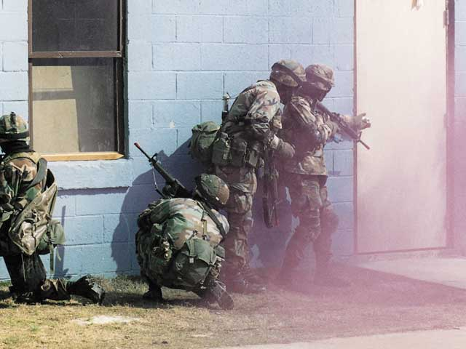
US troops practicing urban warfare techniques

When crossing alleys, one man should be ready to provide covering fire while everyone else rushes across en masse. This way the rest of the team is in position to cover the lagger and the enemy doesn’t have time to take aim.

Buildings can easily be modified into hardened fighting positions. Walls can be reinforced with sandbags to waist level (which stop rifle bullets very well), windows can be covered with mesh screens to keep out grenades, firing slits for rifles can be cut into walls and unneeded windows and doorways can be blocked up. Escape routes into other buildings can easily be arranged by a few whacks with a sledgehammer. With a team’s machinegun covering the main approach and riflemen in the corners, a house can be effectively defended by very few men. Fortified-looking dummy positions are a great way to throw off attackers.

Rooftops provide great fields of fire and are great positions for snipers. Troops on rooftops are generally safe from tanks and can drop Molotov cocktails on them with relative impunity. This means that soldiers will concentrate a lot of firepower on the roofs when they suspect an attack from above, so stealth and pre-planned escape routes are vital.

And always keep these points in mind:

“Nine or You’re Mine!”
1. Stay alert and quiet, especially while moving.
- Move fast.
- Never present a silhouette—move at a crouched run.
- Select your next position before beginning to move.
- Always avoid open spaces and make sure to hug the side of buildings wherever possible.
- Use cover and concealment to hide your movements whenever possible.
- Use smoke when crossing open areas.
- Make sure to avoid getting caught in your own cover fire.
9. Don’t bunch up!

Airmobile Operations

One advantage available to well-equipped and properly trained units is airmobile deployment. Assuming that allied forces have, at least temporarily, sufficient control over the skies to permit slow-moving troop transport aircraft to move safely, airmobility allows troops to strike deeper behind enemy lines with minimal warning or potential for ambush.
The classic method of airmobility is paratrooping. Most elite units receive parachute training, although few ever make combat use of it because it is so risky-- soldiers are visible and vulnerable to enemy fire for quite some time, and are often widely scattered. A disorganized, lightly-equipped unit stranded deep behind enemy lines without support is going to get beaten severely no matter what it does. Air drops are high-risk, high-gain operations that smart commanders will use sparingly. HALO jumping is a variation on conventional parachute air drops used by special forces. The idea is to avoid detection by dropping at very high altitudes and opening the chute very close to the ground. Of course, landing undetected doesn't do you much good if you screw up and leave a commando-shaped crater in your drop zone...

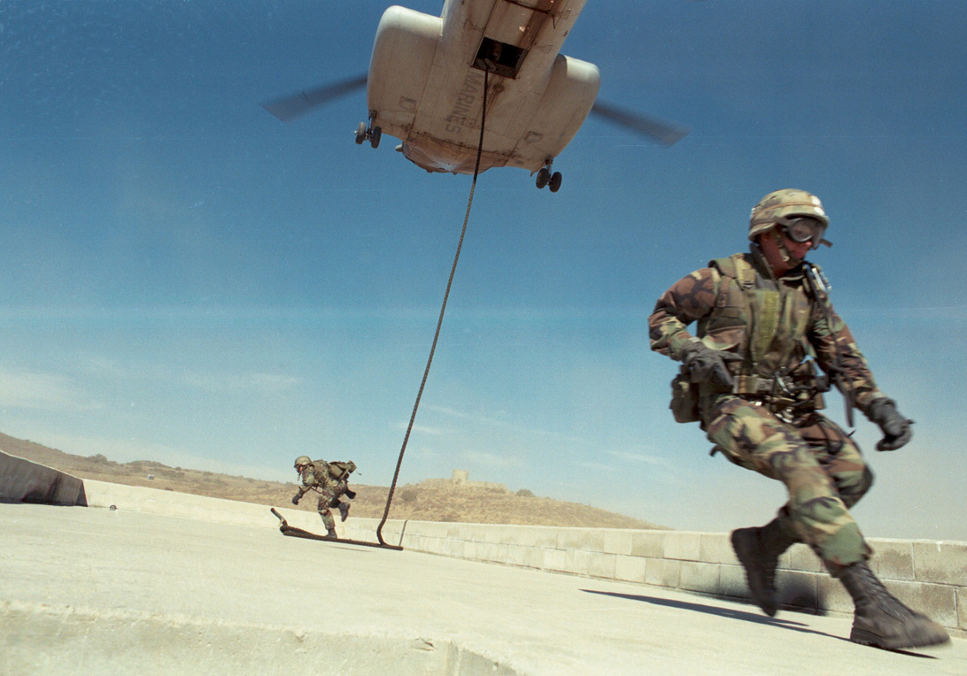
The U.S. developed air cavalry in the early ‘60s and now heavily utilizes helicopters to deploy and extract infantry forces. While helicopters have many advantages of airdropping and less of the inherent riskiness, they do have several limitations. First is the expense. Helicopters are expensive to buy and even more expensive to maintain in safe running order. They are very sensitive to bad weather and can crash easily in poor conditions. More seriously, they are relatively slow by aircraft standards and therefore easy targets for both air and ground launched guided missiles. Even unguided rockets can take down helicopters with a lucky shot (which will eventually happen when there's lots of them being fired at you, as we learned in Vietnam and relearned in Mogadishu), especially if the helicopter is stationary while unloading troops. Therefore different methods of troop deployment have been developed, each with different trade-offs between the safety of the troops being deployed and the safety of the helicopter itself. For the troops, the safest technique is obviously to actually land the helicopter, but this safety means little if the helicopter is hit by a rocket while they are onboard. In Vietnam, pilots solved this problem by hovering at a height of 4 to 10 feet and having the troops jump out. This led to some sprains and breaks, but it proved safest for the squad overall. Modern air-assault forces practice "fast-roping" or sliding down a rope from heights of 20 to 50 feet. This has proven to be an ideal method for well-trained troops.
US Air Assault Troops fast-roping from a CH-46 Helicopter

While elite military forces are usually airmobile, not all airmobile units are considered elite. However, because Airmobile troops are usually the most likely to be deployed in a hurry, and therefore tend to be given better than usual equipment and training.

Special Operations
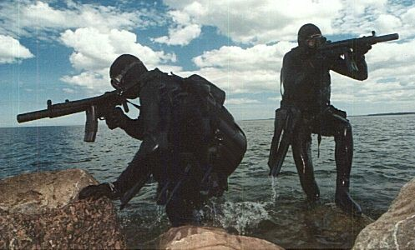
Special Operations include pretty much any imaginable operation not described above. This includes practicing guerilla warfare, demolition of strategic targets, assassination, hostage rescue, etc.

There are relatively few hard and fast rules in conducting special operations, but any such op relies heavily on good intelligence information- they NEVER just get up and go on a mission like you may see in bad movies. Operations are planned meticulously and rehearsed many times, and each trooper will learn to do the jobs of several of his comrades in case things go wrong. The most difficult part of such operations is exfiltrating safely. This usually requires a lot of creativity. Beyond this, the best way to learn the methodology of special operations is to read about successful (and failed) operations from the past, such as the Israeli raid on Entebbe, the US POW rescue mission carried out at Song Tay, or the US Ranger missions conducted around Omaha beach.
Estonian SOG units practice amphibious infiltration

Another common task given to special forces teams is the training of friendly local forces. This can mean training the locals to wage guerrilla operations against the government or to improve the regular military troops. Most SF troops have spent time in conventional infantry units and have acquired considerable training and experience even before being trained as an operator. If you were to look at the staff roster for a SF team you would see a disproportionate number of higher-ranking individuals, most of whom would be in command of a lesser unit (and usually were at one time). This experience makes them ideal both for training local troops and the specialized missions they are best known for.

Conclusion

The proper use of tactics will exponentially increase a small unit’s odds of survival. Their value cannot be overstated. But by themselves, even strength and good tactics will not necessarily be decisive. To be truly effective, a unit must have a strong will to fight and courage under fire, two things that no amount of training can ensure. The best way to instill bravery and aggressiveness in soldiers is to provide them with leaders they trust, a cause they believe in, and to encourage a sense of brotherhood and camaraderie amongst them. When heroes are asked why they did the seemingly insane things they’ve done, they most often answer that they did it because they knew their comrades were depending on them.

One last word on tactics: BE FLEXIBLE! Warfare is constantly changing and even the densest combatant will eventually learn his adversary’s methods of operation and find ways to exploit them. Don’t fall into predictable patterns and don’t be afraid to learn from your enemies.

For more information:

Web sites:
http://www.gamesofwar.de/Tactics/recon.html, http://web.qx.net/warcat/MilSF/essays1.htm,
especially http://www.gamesofwar.de/Tactics/defensive.html on digging foxholes.
The US Army field manual site http://www.adtdl.army.mil/cgi-bin/atdl.dll?type=fm, especially FM 7-8 http://www.adtdl.army.mil/cgi-bin/atdl.dll/fm/7-8/toc.htm on Infantry squad and platoon.
http://www.stormpages.com/garyjkennedy/Tactics/Formations/rifle_squad.htm on the development of the post-WWII rifle squad.
http://www.unc.edu/depts/diplomat/AD_Issues/amdipl_17/articles/deatkine_arabs2.html on “Why Arabs Lose Wars,” A list of major organizational and cultural blunders military units need to avoid by Norvell B. De Atkine
http://denbeste.nu/cd_log_entries/2003/12/Thefourelementsofwarfare.shtml an essay on objectives, strategy, tactics, logistics, and morale as they apply to the U.S. occupation of Iraq.

Books:
How to Make War by James F. Dunnigan, Black Hawk Down by Mark Bowden, Starship Troopers by Robert A. Heinlein, Ender’s Game by Orson Scott Card, Clear and Present Danger and Red Storm Rising by Tom Clancy.

Movies:
Black Hawk Down, We Were Soldiers, Full Metal Jacket, Saving Private Ryan, Enemy at the Gates. (in roughly that order of importance)

Appendix A

An example of a firefight between a professional unit and one that is not:

A Marine patrol is stalking through the jungle on a search and attack mission. Suddenly the point man comes under fire and hits the ground. The Automatic Rifleman, behind the pointman, opens fire on the suspected enemy position, firing as fast as he accurately can. The third man in formation (with a grenade launcher) starts to fire on the enemy also. As quickly as it can, the Marines will bring as much firepower as they can on the enemy and will get in a line facing the enemy. There will usually be enough room between Marines so that a single grenade will not kill more than one or two. The point man might have a higher content of tracers in his weapon to designate the enemy's location and because tracers help with suppression.

Grenade launchers will fire smoke, as well as explosives to mark the enemy location for those that don't yet see the enemy. The smoke would interfere with the enemy's ability to see the Marines and it will tell the Marines about where the enemy is at, the smoke is also less likely to interfere with the Marine's ability to see. Fireteam leaders will order their fireteams to concentrate fire on those locations.

If the Marines have managed to suppress the enemy, the squad leader may send a fireteam to the side of the enemy and assault him from there (flanking). If this fails or is not practical then the squad leader will get on his radio and call for mortars or artillery (if he hasn't done so already). Also, reinforcements might be dispatched by higher authorities.

If the enemy fire is too strong and the Marines are taking casualties then they will retreat under cover of mortars, artillery, close air support or Naval gunfire. If the squad leader believes he cannot flank the enemy and the squad can assault them he will give the order. At this point he can advance the squad by fireteams, or give the fireteam leaders control.

While two fireteams lays down a high volume of fire, and suppresses the enemy, another fireteam will advance. Meanwhile, fireteam leaders are directing their teams to advantageous positions, with the machine gunner taking priority. If there is a target that the machine gunner is having difficulty with then the team leader will engage it with his grenade launcher. Also, Marines on either side of the line will be told to be more watchful so the Marines don't get flanked.

If the squad leader has a machine gun team (with a medium machine gun) it will receive the best firing position in the squad and remain as stationary as possible. A rocket team will be used against fortified targets or difficult enemy hold-outs as directed by the squad leader (or team leader). All Marines will place a priority on killing enemy machine gunners, radio operators and leaders, and concentrate fire accordingly.

If the vegetation is too thick and the squad leader is having difficulty controlling the squad, the squad leader may order the fireteam leaders to advance their teams. The fireteam leaders can advance their people two ways, in battleteams of two, or he can move one person at a time while the rest of the team 'pins' down the enemy. These methods can be alternated depending on the terrain and situation. If the fireteam does not have a target it will advance until it does or is fired at. A good unit does not waste ammo, because it also gives them away and even when rounds are flying all over the place an individual can still surprise his enemy.

If a team goes to battleteams then one person will move while the other covers. The person that moves will not run far and will have something to hid behind when he gets there. Usually, the Marine gets prone behind something that can protect him from enemy fire, or at least provide him with a little concealment. It is important to note that a person does not always get and run forward. The Marine might crawl forward and he is unlikely to just stop in the open and get down if there is not cover.

During the attack (or retreat since everything can be done in reverse) professionals are always communicating. Fireteam leaders tell their teams where to concentrate their fires, team members yell out when and where they see the enemy, everyone yells out when they are running low, or reloading, when they have taken cover and firing (so the other person can get up and move). Fireteam leaders and members should also communicate with their fellow Marines on either side regardless of fireteam or unit.

Squad leaders are always moving around, directing fireteam leaders, machine gunners, or, occasionally, firing at the enemy.

With all the communication, massive amounts of fire are directed on specific targets which are quickly killed or suppressed. (Having four men fire at you with everything from grenade launchers, rifles and machine guns is very intimidating or fatal.)

Once the Marines get close to the enemy positions they may begin throwing hand grenades. In the jungle this can be dangerous because a grenade may hit a branch and bounce back. To avoid having grenades thrown at them as they get closer, Marines may decide to 'assault'. This is little more than a banzai charge for a short distances. Firing from the shoulder (since they are closer it is much easier to hit) the Marines charge into the enemy positions and engage them in close combat. Hopefully, the enemy is dead and unable to fight back at this time. Battle cries and 'war faces' also help intimidate the enemy into fleeing or not firing back. These tactics can have more effect than most people would credit them with.

All this might sound simple but that is the last thing it is. Confusion and chaos reign supreme. If a unit or person gets too far ahead of the rest he mind find himself with enemy in front and either side. Needless to say, this is very dangerous (but he can take advantage of the enemy on his sides if they are concentrating on his fellow Marines in front of them.)

Additionally, there are a great many tactics that can be used to give the defenders an advantage such as machine guns that are shooting an X across the front. This creates a wall of lead which is difficult to cross. The enemy will also be trying very hard to gain fire superiority and may even try to flank the Marines. They will have their own rockets and special weapons. A great many factors affect who will win with the edge going to the more professional warriors who know their trade.
Appendix B

Every soldier should understand how to react to the following signals.

Freeze: Everybody hold your position. All the soldiers should stay quiet and motionless. It usually means that the Point Man (or whoever made the signal) suspects that something is wrong and is still gathering information.

Hasty Ambush: Means "we're going to ambush the enemy". Usually made when the enemy looks vulnerable and when they seem to be heading toward the group. The soldiers should immediately take concealed firing positions.

Attack! or Immediate Assault: Not the kind of thing you do every day! For some reason, everybody should charge with weapons blazing. For example, if the group comes on the rear of an enemy position, or if another friendly unit needs immediate help. Also used on raids. Whoever gives the signal had better have a damn good reason.

Fall back: This means to start an orderly, guarded retreat. Usually done with the leapfrog method where one or two men at a time go back down the trail while the others stand guard. When the operation is complete the whole group should be back in their usual marching order, but heading in the opposite direction.

Ambush: Or, to put it another way, RUN! It means that the group is in immediate danger of being in an enemy ambush.

Incoming: Means "TAKE COVER!" Some kind of indirect fire, like a mortar or an artillery shell, is coming into the group. Everybody should hit the dirt, scatter or find cover immediately.

Sniper: Reacting to a single sniper is a little different than reacting to an ambush. The entire group should open fire on the sniper's position. This may or may not kill the enemy, but it'll suppress his fire for the moment.

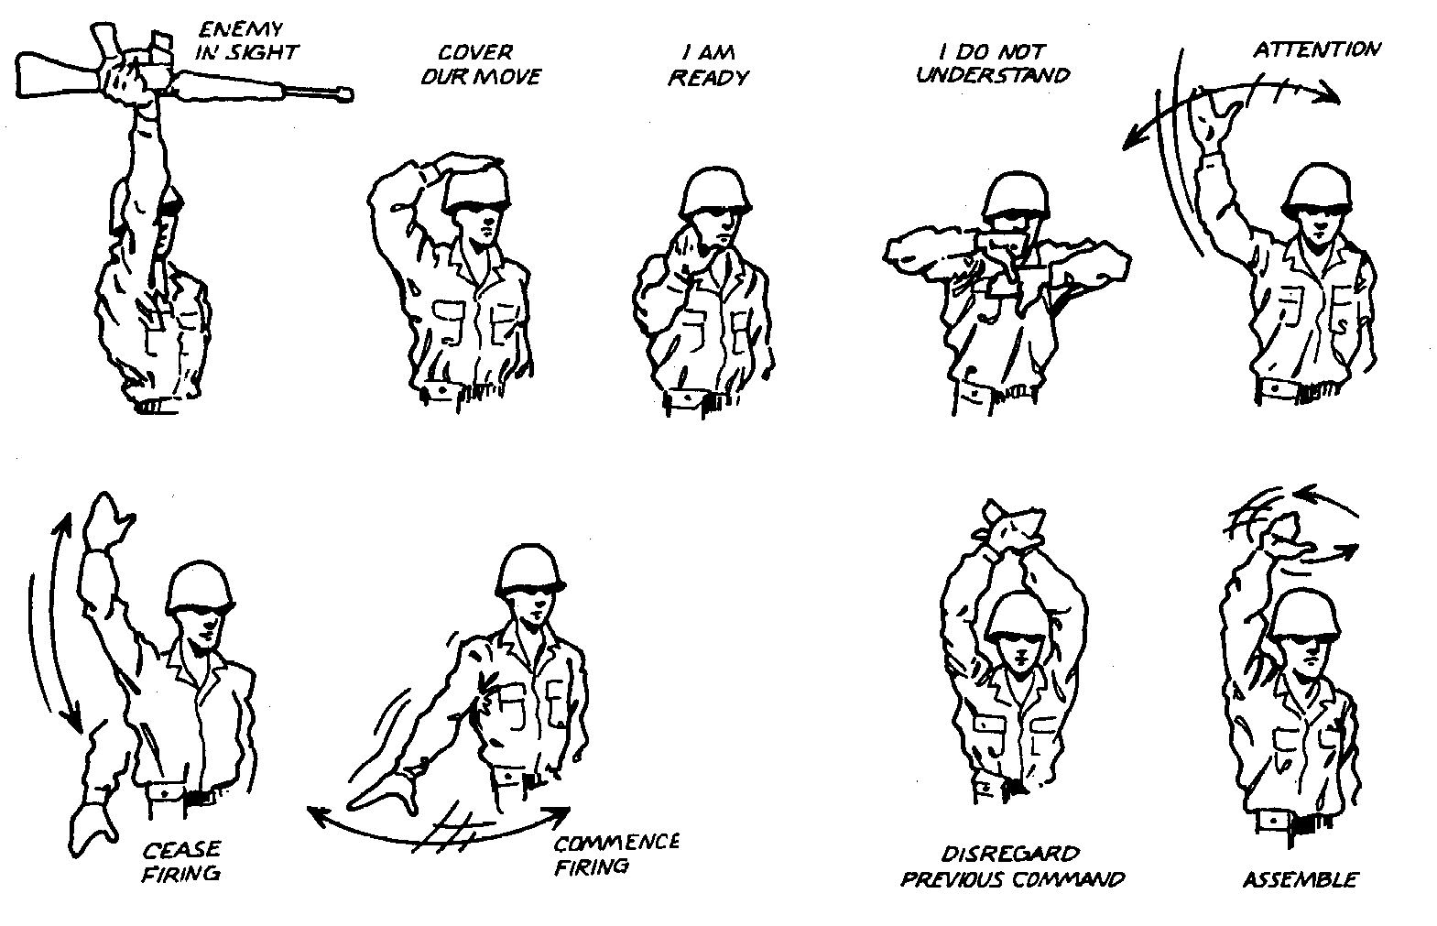

Modern rifles are the product of several technical innovations, mostly made in the late 19th century: 1. They load from the breech, not the business end of the weapon. This allows riflemen to fire and reload without having to stand up like they did in colonial times. 2. They fire self-contained metallic cartridges, rather than bags of gunpowder and bullets. This makes ammunition more durable and portable, allowing multiple cartridges to be stored, ready to shoot instantly. 3. They harness some of the excess energy released with each shot to mechanically reloading themselves, leaving the shooter free to maintain his aim between shots and keep firing constantly until he runs out of ammunition. 4. Detachable magazines that allow shooters to rapidly refill their weapons with ammunition. 5. They use "intermediate" powered cartridges less powerful than the rifle cartridges used 50 years ago, allowing better control on full-auto at the expense of some range. These rounds are still roughly 3 times as deadly as pistol cartridges and offer roughly 10 times the effective range.

